*This mod must be used with the TerraFirmaCraft mod for Minecraft.*

## Introduction

The idea behind this mod came from the frustration of trying to remember the alloy mixes in TFC. I kept constantly referring to the wiki, or even downloading one of the few alloy calculator spreadsheets. I even tried the online web version.

But they all meant I had to leave TFC and enter the real world to get my answers. Also if in future the developers of TFC refined the alloy mixture ratios, then I would have to wait for the wiki, spreadsheets or online website to be updated.

One problem I had with the spreadsheets and online website was that they only used ores, they did not account for items being added to the crucible (eg. anvils, unfinished armour, ingots, double ingots etc) that could be smelted back to the metal.

What I really wanted was a way to measure of the alloy ingredients in game, so I could stay immersed in TFC. I also wanted it to read the alloy mixture ratios directly from TFC, so if any changes were made, they would be effective immediately. I also wanted a way to see in game, which alloys could be made, just by putting in a mixture of ores and smeltable items.

## Items

1. Alloy Calculator – a metal measuring and information device.

## Recipes

### Alloy Calculator

The alloy calculators are made using five of any lumber and one chipped gem.

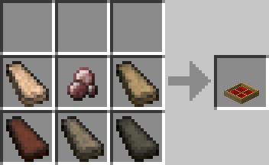

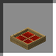

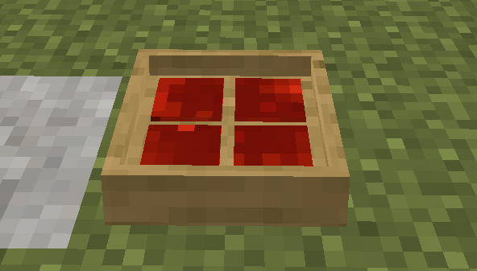

## Process

### Calculating Alloys

The main use of the alloy calculator is to measure ores and smeltable items into the ratio needed to make the alloy. Open the Alloy Calculator UI by right-clicking. Change to the tab with this symbol



Then by added and removing ores and smeltable items, you can adjust the mixture to find the ratio to make your required alloy (as seen in the images below).

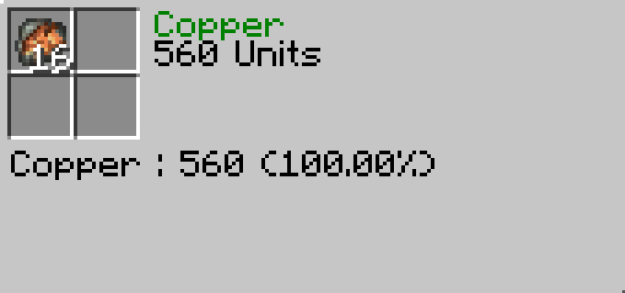

This image shows the result of just adding a valid ratio of Copper ore to the calculator, the result is Copper.

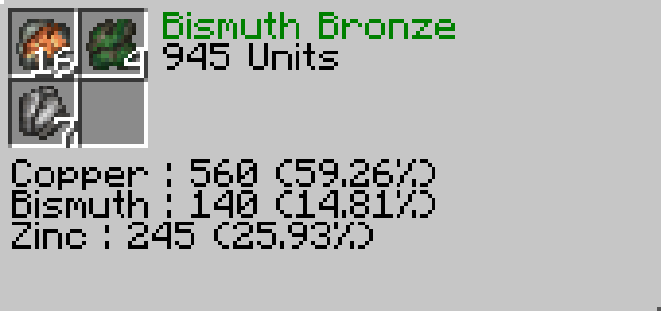

This image shows the result of adding a valid ratio of Copper, Bismuth and Zinc ore, the result is Bismuth Bronze.

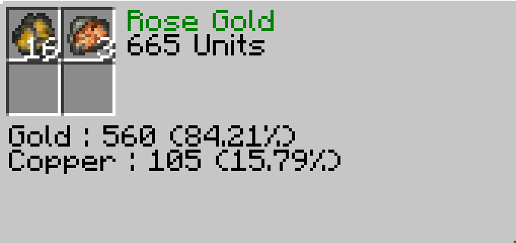

This image shows the result of adding a valid ratio of Gold and Copper ore, the result is Rose Gold.

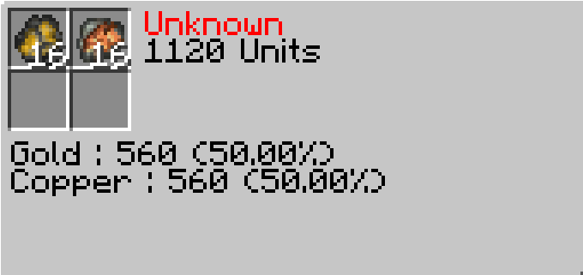

This image shows the result of adding Gold and Copper ore in a ratio that is invalid, the result is Unknown.

### Possible Alloys

The second function of the alloy calculator is to provide possible alloys based on the ore and smeltable items added to the calculator. To use this function, you need to add one or more ore or smeltable items to the calculator, then change to the tab with this symbol



The possible alloys tab will show you which alloy can be created using the resources add to the calculator and the percentage ratio required. Using this information you can then adjust the amount added to the calculator to get the correct alloy mixture.

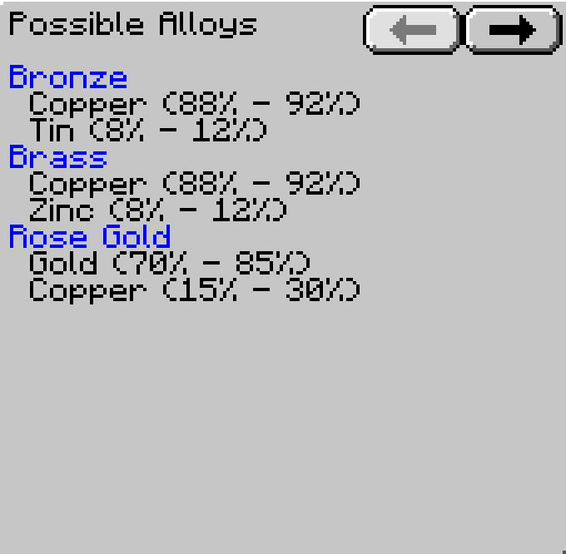

This image shows the possible alloys after adding a stack of Copper ore to the calculator. In this scenario, there are more than three results, indicated by the enabled arrow button in the top right corner. Using this arrow, you can see the other results.

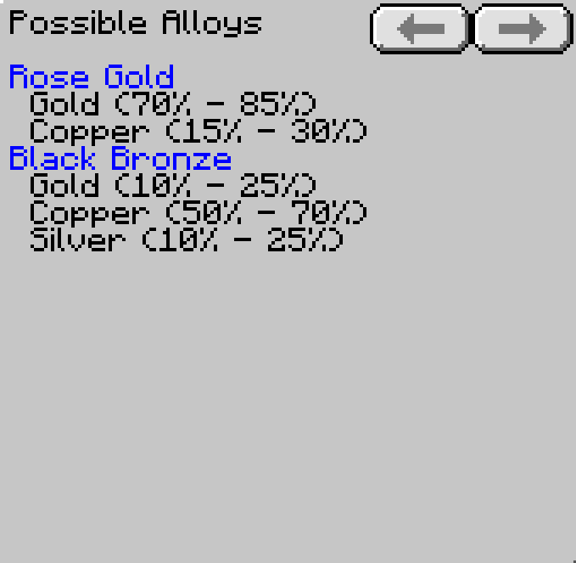

This image shows the possible alloys after adding a stack of Gold ore to the calculator. In this scenario, there are only two results.

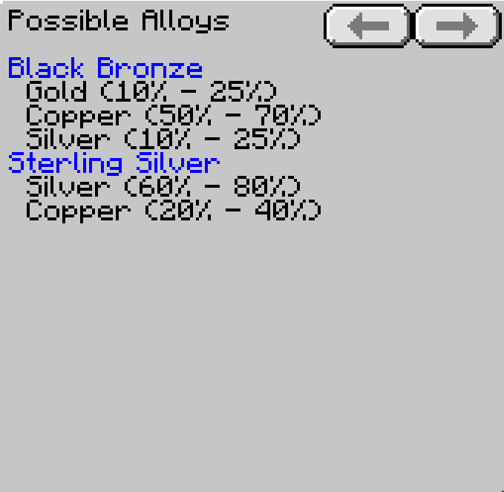

This image shows the possible alloys after adding a stack of Silver ore to the calculator. In this scenario, there are only two results.

## Additional Information

1. The Alloy Calculator uses the alloy ratio values from within TFC directly, so any changes to the alloy ratios will be effective immediately.
2. The calculator can use any ore or smeltable item in game (e.g. anvil, unfinished armour, ingots etc.).
3. If another TFC mod has items that inherit the TFC ISmeltable interface, it should be able to be used with the Alloy Calculator.
4. Alloy calculators can be stored in chests.
5. Alloy calculators are **not** stackable.
6. If the player right-clicks the alloy calculator while sneaking, the item is transferred into the players hand. Your hand must be empty.